Sprint 2 – Accuracy Design Document

April 6, 2023

Table of Contents

1. Executive Summary 2

1.1 Project Overview 2

1.2 Purpose and Scope of this Specification 2

2. Product/Service Description 2

2.1 Product Context 2

2.2 User Characteristics 2

2.3 Assumptions 3

2.4 Constraints 3

2.5 Dependencies 3

3. Requirements 3

3.1 Functional Requirements 3

3.2 Security 4

3.2.1 Protection 4

3.2.2 Authorization and Authentication 4

3.3 Portability 4

4. Requirements Confirmation/Stakeholder sign-off 4

5. System Design 4

5.1 Algorithm 4

5.2 System Flow 5

5.3 Software 6

5.4 Hardware 7

5.5 Test Plan 7

5.6 Task List/Gantt Chart 8

5.7 Staffing Plan 8

# Executive Summary

## Project Overview

This project serves to prove the capabilities of the Sphero Sprk+ in following a designated course, marked by blue tape, when given a specific set of instructions. The robot will change speak and flash colors at the end of the course.

## Purpose and Scope of this Specification

The overall purpose of the accuracy test is for the Sphero Sprk+ to successfully navigate in a figure 8 shape on a designated track 5 times.

For example:

In scope

This document addresses requirements related to phase 2 of Project A:

* Sphero Sprk+ completes 5 figure 8 loops around the designated tape.
* The robot ends at the same location that it started.
* At the end of the course, the robot says, “I am the winner!”
* The robot will strobe different colors for 5 seconds at the end.

Out of Scope

The following items in phase 3 of Project A are out of scope:

* The Sphero Sprk+ does not follow the blue tape.
* The Sphero Sprk+ does not end in the same place it started.
* The robot does not speak as directed.
* The robot does not strobe colors as specified.

# Product/Service Description

* The project is for CS-104-01.
* The project is due on April 6, 2023
* The majority of the project will take place in HH 208 outside of class hours.

## Product Context

The test is an independent test that is self-contained. It is one of 3 tests that are all part of the larger Sphero Sprk+ capabilities test. The robot works with Sphero software that can be run on computers or mobile phones. It utilizes Bluetooth to connect to the devices.

## User Characteristics

* Student
* 1 to 4 years of university experience
* Limited knowledge of Sphero Sprk+ software
* Limited knowledge in software engineering and project development
* Developer of the project
* Faculty
* Years of experience in software engineering and project development
* Higher level of knowledge in Sphero Sprk+ software
* Supervisor/reviewer for the project

## Assumptions

* The robot is assumed to follow directions exactly as told.
* The room, HH208, is assumed to be available for testing.
* The code is assumed to work as needed.

## Constraints

Describe any items that will constrain the design options, including:

* There is a limited amount of time to use HH208 since it is occupied throughout the day by other classes.
* The developers do not have an extensive knowledge of the Sphero Sprk+ software.
* The software and robot can be at times temperamental, and though it may follow the same lines of codes, it may turn at slightly different times, travel at different speeds, and result in different geographical movements.
* When looping, the robot is not lined up and therefore not on the tape for the entire run.

## Dependencies

List dependencies that affect the requirements.

* This project will require team members to work on it equally.
* The robot must complete a series of tests before completing a final run.
* The accuracy sprint must take place in HH208.

# Requirements

## Functional Requirements

In the example below, the requirement numbering has a scheme - BR_LR_0## (BR for Business Requirement, LR for Labor Relations). For small projects simply BR-## would suffice. Keep in mind that if no prefix is used, the traceability matrix may be difficult to create (e.g., no differentiation between '02' as a business requirement vs. a test case)

The following table is an example format for requirements. Choose whatever format works best for your project.

For Example:

| Req# | Requirement | Comments | Priority | Date Rvwd | SME Reviewed / Approved |
| --- | --- | --- | --- | --- | --- |
| ACCUR_01 | The Sphero Sprk+ (robot) will navigate around the figure 8 loop by following the blue tape. | This is necessary in order to prove that the robot can navigate the course. | 1 | 4/4/23 | Alex Kalina |
| ACCUR_02 | The robot will successfully navigate around the infinity loop 5 times. | This is needed in order to receive full credit for the project. | 2 | 4/4/23 | Daniel Trocchia |
| ACCUR_03 | The robot will speak after navigating the blue tape successfully. | This is needed in order to indicate completion and to receive full credit for the project. | 3 | 4/5/23 | Alex Kalina |
| ACCUR_04 | The robot will strobe and flash colors for 5 seconds. | Necessary in obtaining full credit. | 4 | 4/5/23 | Daniel Trocchia |

## Security

### Protection

* The computer that has access to the Sphero software requires a password in order to unlock it.
* The Sphero software has a login, preventing unwanted users from accessing the block codes.
* There is an additional backup of the software in case the first one became corrupted or deleted.

### Authorization and Authentication

A Sphero account is required to access the block code. This Sphero account needs a login and passcode, and the email needs to be verified.

## Portability

* The robot takes advantage of code that is located on the MacBook Pro
* Sphero can be used on nearly any device ranging from computers that utilize windows, and macOS or android and IOS.
* The code requires a Bluetooth connection to connect to the robot and run, however the code is entirely dependent on the host.

# Requirements Confirmation/Stakeholder sign-off

|  |  |  |
| --- | --- | --- |
| Meeting Date | Attendees (name and role) | Comments |
| 04/03/23 | Alex Kalina (developer), Daniel Trocchia | confirmed all, rough outline for accuracy run |
| 04/06/23 | Alex Kalina (developer), Daniel Trocchia | Confirmed all, final revisions made |

# System Design

This section will provide all details concerning the technical design, staffing, coding, and testing the system

## Algorithm

1. The robot will begin at the designated point, at the cross section of the two circles.
2. The robot will begin to move.
3. The robot will travel in one circle all the way back to the starting position.
4. The robot will travel continue past the cross section.
5. The robot will travel across the next circle.
6. The robot will return to the cross section.
7. The robot will repeat steps 3-6 four more times.
8. The robot will stop at the cross section.
9. The robot will say, “I am the winner!”
10. The robot will flash multi-colored lights for five seconds.

## System Flow

## Software

Sphero Edu software, Github.com, Microsoft Word and Excel.

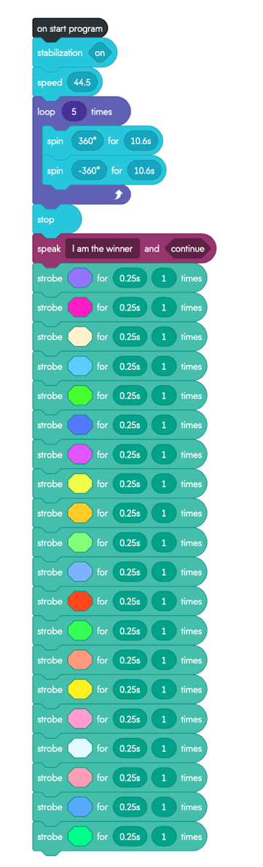

## Hardware

Sphero Sprk+ robot, Sphero robot charger, Apple MacBook Pro, iPhone.

## Test Plan

Include a test plan showing all unit tests performed for this application, Include test rational, test date, staff member, pass/fail status

| **Reason for Test Case** | **Test Date** | **Expected Output** | **Observed Output** | **Staff Name** | **Pass/Fail** |
| --- | --- | --- | --- | --- | --- |
| Align Robot | 4/3/2023 | Robot will move in right direction | Robot moved in wrong direction | Alex Kalina | Fail |
| Align Robot | 4/3/2023 | Robot will move in right direction | Robot moved In right direction | Alex Kalina | Pass |
| Turn properly | 4/3/2023 | Robot will circle around the blue tape | Robot did not circle around tape | Alex Kalina | Fail |
| Turn properly | 4/3/2023 | Robot will circle around the blue tape | Robot Circled around tape | Alex Kalina | Pass |
| Turn Properly 2x | 4/4/2023 | Robot will follow the whole figure 8. | Robot did not follow whole figure 8. | Daniel Trocchia | Fail |
| Turn Properly 2x | 4/4/2023 | Robot will follow the whole figure 8. | Robot followed whole figure 8. | Daniel Trocchia | Pass |
| Complete path | 4/4/2023 | Robot will circle around 5 times. | Robot circled around 5 times | Daniel Trocchia | Pass |
| Functionality | 4/5/2023 | Robot will speak when prompted | Robot spoke when prompted | Daniel Trocchia | Pass |
| Functionality | 4/5/2023 | Robot will flash multi-colored lights. | Robot flashed multi-colored lights | Alex Kalina | Pass |
| Full Run | 4/5/2023 | Robot completes all tasks as prompted | Robot did not complete all tasks | Alex Kalina | Fail |
| Full Run | 4/5/2023 | Robot completes all tasks as prompted | Robot completed all tasks | Alex Kalina | Pass |

## Chart, bar chart Description automatically generatedTask List/Gantt Chart

## Staffing Plan

Insert a chart/table that depicts the roles and responsibilities of each team member that worked on this project

| Name | Role | Responsibility | Reports To |
| --- | --- | --- | --- |
| Daniel Trocchia | Developer | Participate in various tasks regarding the success of the project. | Alex Kalina |
| Alex Kalina | Developer | Design and implement block code necessary to run the robot. | Daniel Trocchia |